NURTURE SOFTWARE SOLUTIONS PVT LTD

Table of Contents
1. Introduction 4
1.1 Purpose 4
1.2 Scope 4
1.3 Definitions, Acronyms and Abbreviations 4
1.4 References 5
1.5 Technologies to be used 5
1.6 Overview 5
2. Overall Description 6
2.1 Use-Case Model Survey 6
2.2 WEB Architecture diagram 8
2.3 ER Diagram 9
2.4 Architecture diagram 10
2.5 Data Dictionary 11
2.6 Assumptions and Dependencies 15
3. Specific Requirements 166
3.1 Use-Case Reports 12
3.2 Class Diagram 29
3.2 Supplementary Requirements 31

1. Introduction

Purpose
To develop a fully functional and user interactive product which can perform ubiquitous functionalities within the country to –
- Eradicate the unorganised financial intermediaries
- Encourage thrift amongst the members/public
- Seamless loan disbursal for members of Primary Agriculture Credit Societies.
- Systematic monitoring of loans given to members

Scope
- Create member records with the respective details as mentioned in functional specification document.
- Confirm registration of each member through a system of OTP
with proper KYC norms
- Building of member profile with relevant records to containing fields such as - Personal Details, Professional details, employment details , vocation, asset & liabilities type of account and loan amount
- Assign different tasks to different members?
- Provide documentation to the members about the tasks being added on the facilities being provided by the societies
- Update member records/profile as and when required on an ongoing basis
- Bind all the information provided by the team members at one place and show it to all others.?
- Maintain start date and end date of each task?
- Maintain the overall timeline of the project.?
- To initiate effective and necessary steps in case of defaulters
- To market & encourage savings amongst the members
- To uplift the citizens falling under Below poverty level and classified as minority community
- To assist and uplift the land less/small/marginal farmers
- To encourage forming of Self Help Groups and sustain themselves on their own

Definitions, Acronyms and Abbreviation(To be modified)
(To be verified)
OPM – Online Project Management.
Admin – Administrator.
PM – Project Manager.
HTML – Hyper Text Markup Language.
XHTML – extensible Hypertext Markup Language.
HTTP – Hypertext Transfer Protocol.
JSP – Java Server Pages.
EJB - Enterprise Java Beans.
WAS – Websphere Application Server.
J2EE – Java 2 Enterprise Edition.
DB2 - DB2 Database Management System.
Msg – Messag.
Doc – document.

References (? )

IEEE SRS Format.

TGMC-2008 Sample Synopsis Format.
Problem Definition Provided By TGMC-2008

Technologies to be used (?) (To be modified)

Application Architecture - J2EE

Database Application - DB2

Development tool - Rational System Developer.

Web Deployment Server - WAS.

Designing tool - Rational

Overview
This product is an online tool to enable seamless loan disbursal to members of primary agriculture credit societies. It has features which informs the user about the loan eligibility of a particular member and also calculate arrive at the loan amount to be disbursed sanctioned for a particular member.

Its utility lies in the use of technology aided platform to enable transparent maintenance of records and also help in maintaining viable digital footprints for future references of the society.

It helps in paper-less transactions. Work with accuracy; building of proper MIS; business analysis; proper follow-up; helps the Societies to arrest prospective defaulters.

Both Users and members can work with ease. It is a significant step in the digital transformation strategy to be adopted by the agriculture credit societies.

Overall Description

Use-Case General Product overview:Model member registration and loan disbursal
Register Members with their personal details
Check if loan can be disbursed
Enter Loan amount and eligibility
Administrator/User
View All Details
Administrator/User
Society Members
Update personal details
Edit/Change personal details
Add nominee details

Use-Case :Member registration and loan disbursal

Register Members with their basic details
KYC Specification details- Aadhar number and Voter ID
Capture whether a member is a ‘minor’
Screen 2-Member Profile- Basic Details like Title, First Name etc
Member Module-Scree wise details
Members-Screen 3 captures the “Present Address”
Whether the Member qualifies as poor as per the regulations?
Whether the Member qualifies as a minority as per the regulations?
Type of Land owned by the member
Screen 1-Member Profile- Basic member type details
Member Type Code
Member ID
Employee code
Thrift Deposit
Whether the member is eligible for loan?
Total loan amount for which the member is eligible?
Screen 5-Member Profile- Loan details
Member Module-Scree wise details
Members Screen6-Nominee details
Basic personal details of each nominee
Whether the nominee is a member of the society ?
Nominee Aadhar number
Amount used by the member so far
Members-Screen 4 captures the “Permanent Address”

- Member Screen1-: Basic Member details:
This screen captures basic details of the member like their type of membership
and gives a picture about the savings habit and potential of the individual.
(All field details are not expalined here. Individual fields can be seen in the screen shot)
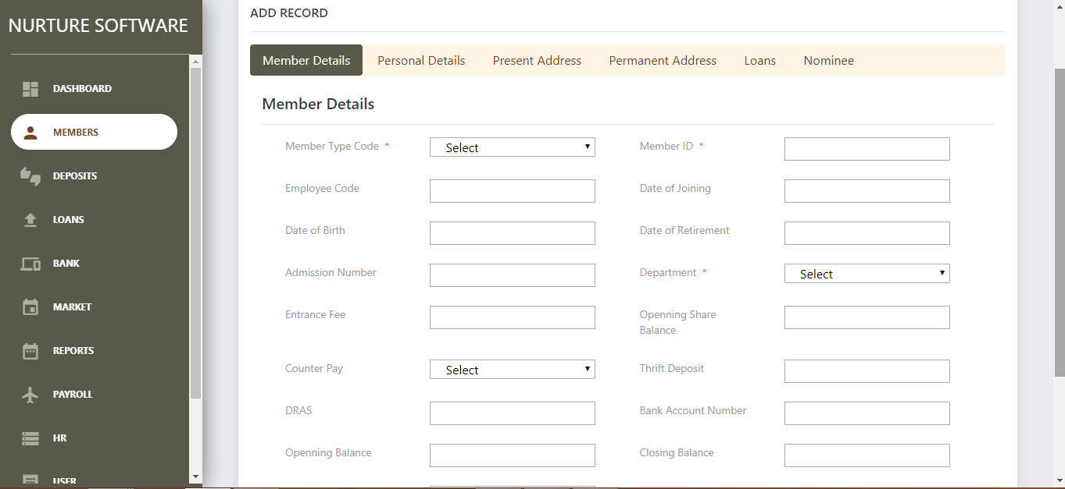

  - Member type: This is captured to ascertain the type of membership-whether he or she is an employee or a member of the society

  - Member ID:- If the individual is a member of the society, then the membership ID is captured.

  - Employee Code: To ascertain the employee code if he or she is a society employee.

  - Thrift Deposit: This field captures the amount of savings of the member

- Member Screen 2-Personal Details: - This screen captures the personal details of the member like name,surname and other important details.
(All field details are not mentioned here. Individual field details can be seen in the screen shot)
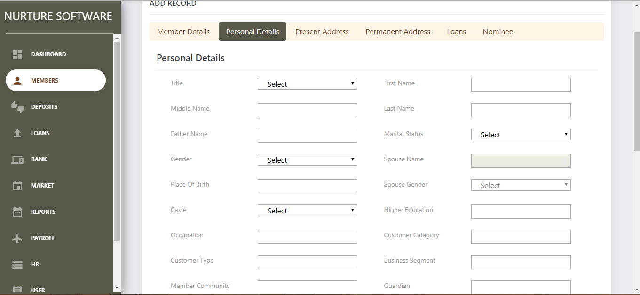

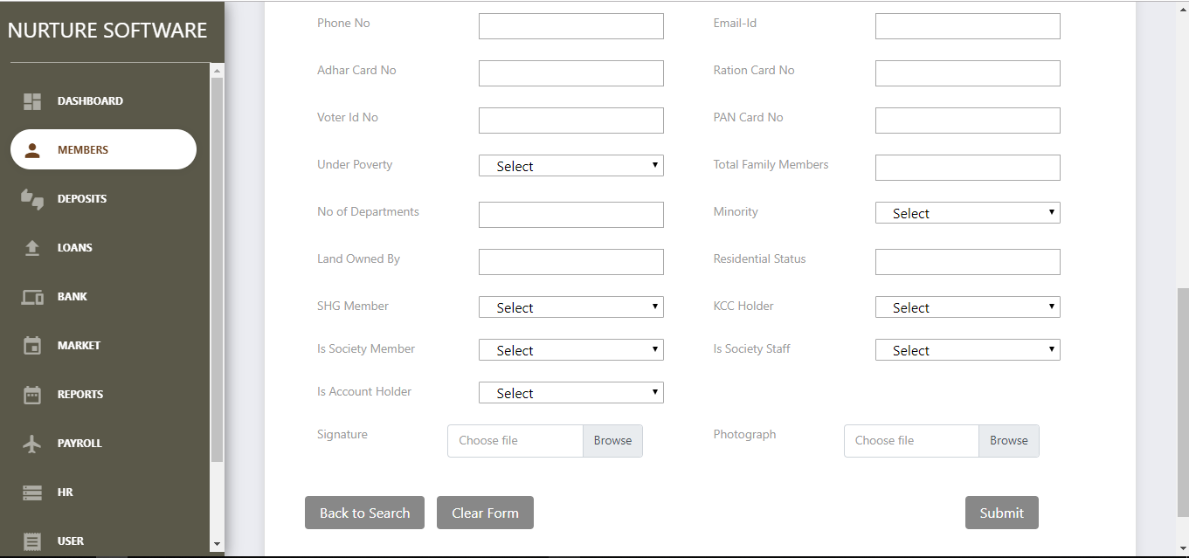

  - Minor: - This field captures whether the member is a minor. This is to ascertain whether to give loans to minors and determine their eligibility.

  - Aadhar No: - This is part of KYC specifications/norms to be fulfilled by the society. Therefore, as part of ID proof / Address proof Aadhar number is captured
  - Voter ID No:-This is part of KYC specifications/norms to be fulfilled by the society. Therefore, as part of ID proof / Address proof Voter ID number is captured

  - PAN no: - This is part of KYC specifications/norms to be fulfilled by the society. Therefore, as part of ID proof / Address proof PAN number is captured

  - Whether Member falls under poverty category: - This is to ascertain whether the member is under BPL(Below Poverty Line category) or not.This is needed to ascertain the loan amount eligibility of the member
  - Whether the Member is a minority:- This captures the minority status of the individual. As part of the Government’s socio-economic inclusion plan, this field is important, so that special positive affirmative action can be taken up in favour of minorities.

  - Type of Land ownership: - Based on type of land ownership viz- Small,Marginal,Large or a tenant farmer, the society can decide the loan amount and the loan eligibility. Therefore, this field is important and hence needs to be captured

- Member Screen 3-Present Address Details: - This screen captures the present address details of the member
(All field details are not mentioned here. Individual field details can be seen in the screen shot)
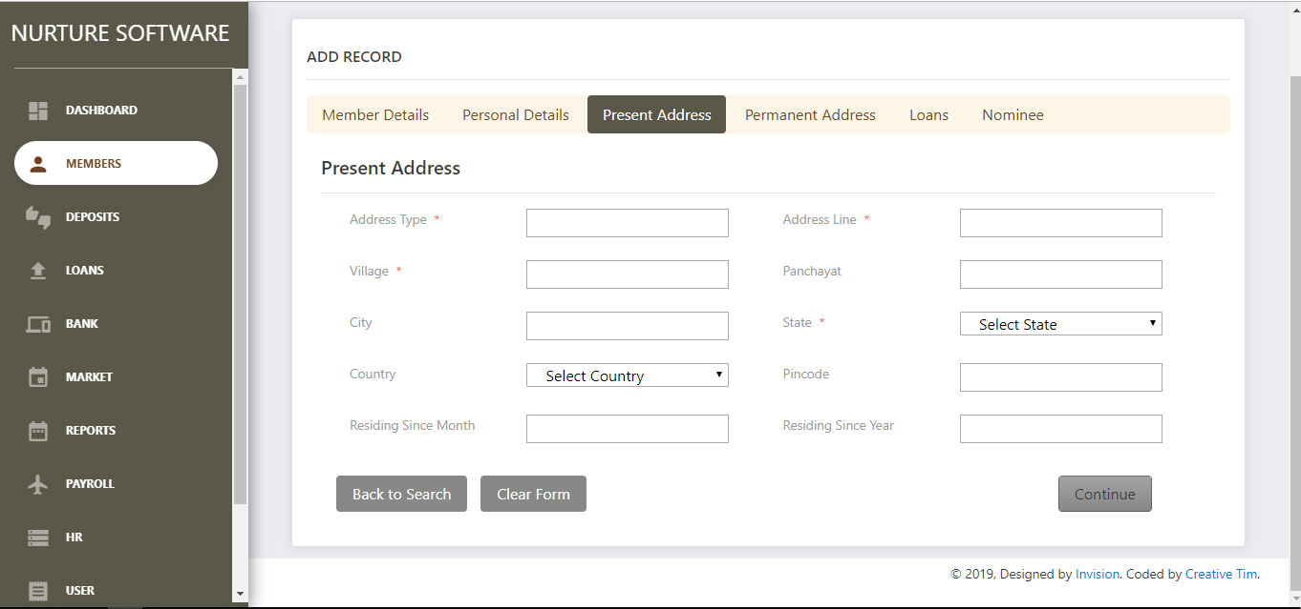

  - Panchayat: - This field is needed to ascertain the name of the Panchayat of the individual. This will give an idea about the local domicile of the member.

  - Period of residence: - This field is needed to ascertain the type of membership that has to be associated with the individual.(For Ex- needs to be clarified)
- Member Screen 4-Permanent Address Details: - This screen captures the permanent address details of the member
(All field details are not mentioned here. Individual field details can be seen in the screen shot)
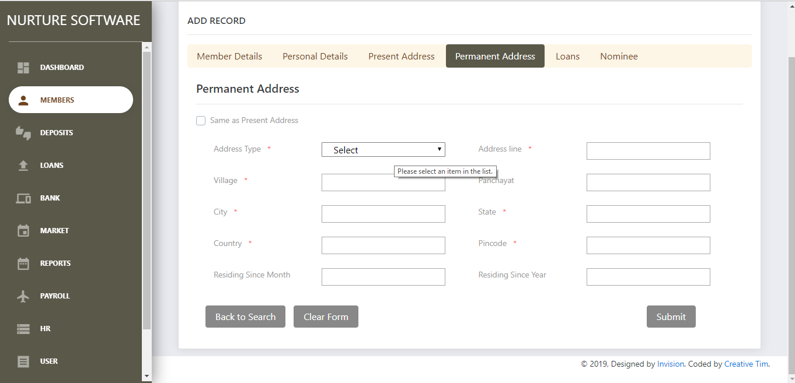

  - Period of residence: - This field is needed to ascertain the type of membership that has to be associated with the individual. In the case where the individual may belong to this village but, his or her parents may be from another village, this field helps us capture the domicile and then associate the type of membership of the individual.

- Member Screen 5-Loan Details: - This screen captures the loan details of the member
(All field details are not mentioned here. Individual field details can be seen in the screen shot)
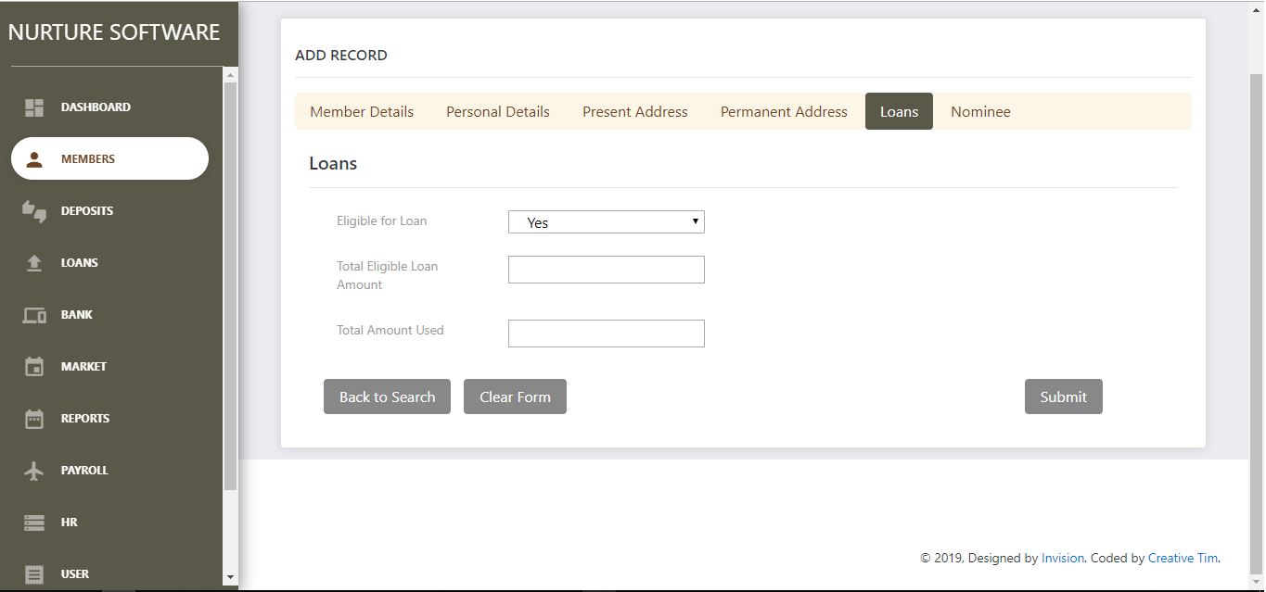

- Whether the member is eligible for loan: - This field captures whether the member is eligible for a loan. If the member has a loan in the past, then it is important to ascertain the eligibility. Thus, this field gives an indication of the same.
- Total eligible loan amount: - This field captures the total loan amount for
Which the member is eligible. It calculates this using various parameters,
One of them being the past loan records of the individual.

- Total Amount used:- If the member has a previous loan amount, this field
Captures the amount of loan used by the member.
- Member Screen 6-Nominee Details: - This screen captures the nominee details of the member
(All field details are not mentioned here. Individual field details can be seen in the screen shot)
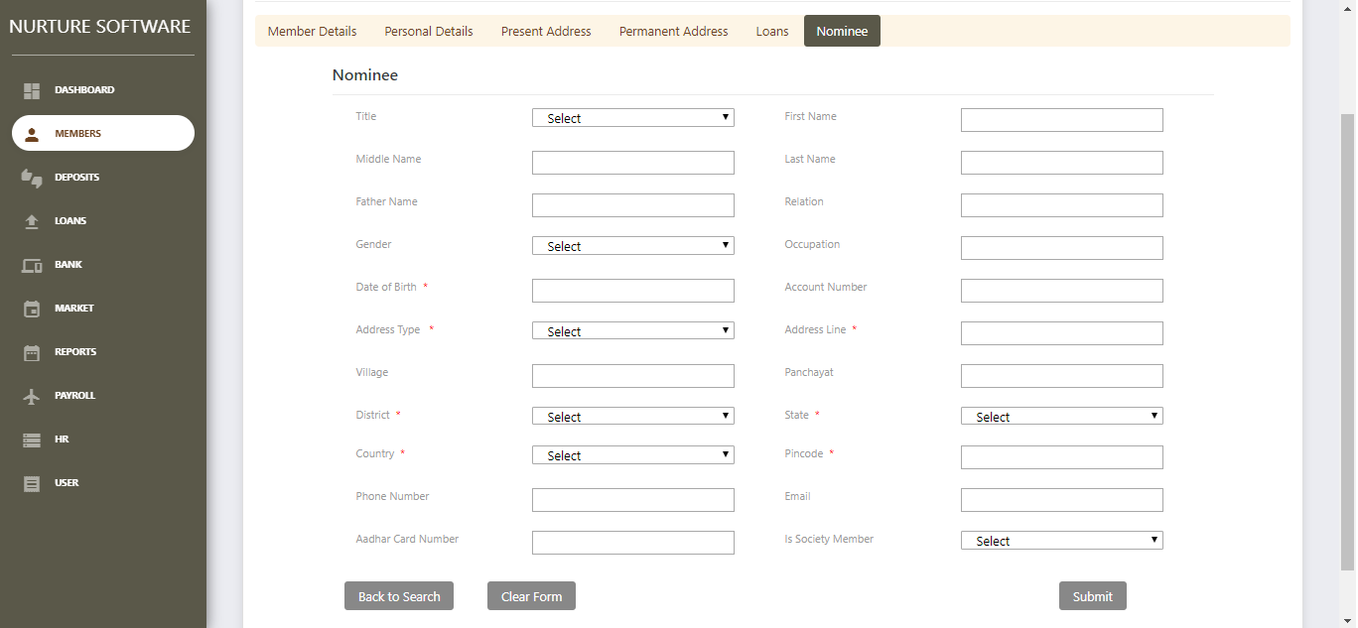

Whether the member is eligible for loan: - The nominee details are needed in case if some member is deceased. In such a case, the loan amount will be transferred or the responsibility of repayment falls on the nominee. Therefore, all basic details of the nominee are captured. The product has the ability to capture more than one nominee .

Web Architecture Diagram

HTML CLIENT
(Customer)
HTTP/HTTPS

DB SERVER
WAS

Client Software
(System Users)
TCP/IP

Client Side Application Side DB Server Side
It uses three tier architecture dig where client side application side and DB server are three diff components that improve security in system.

ER Diagram
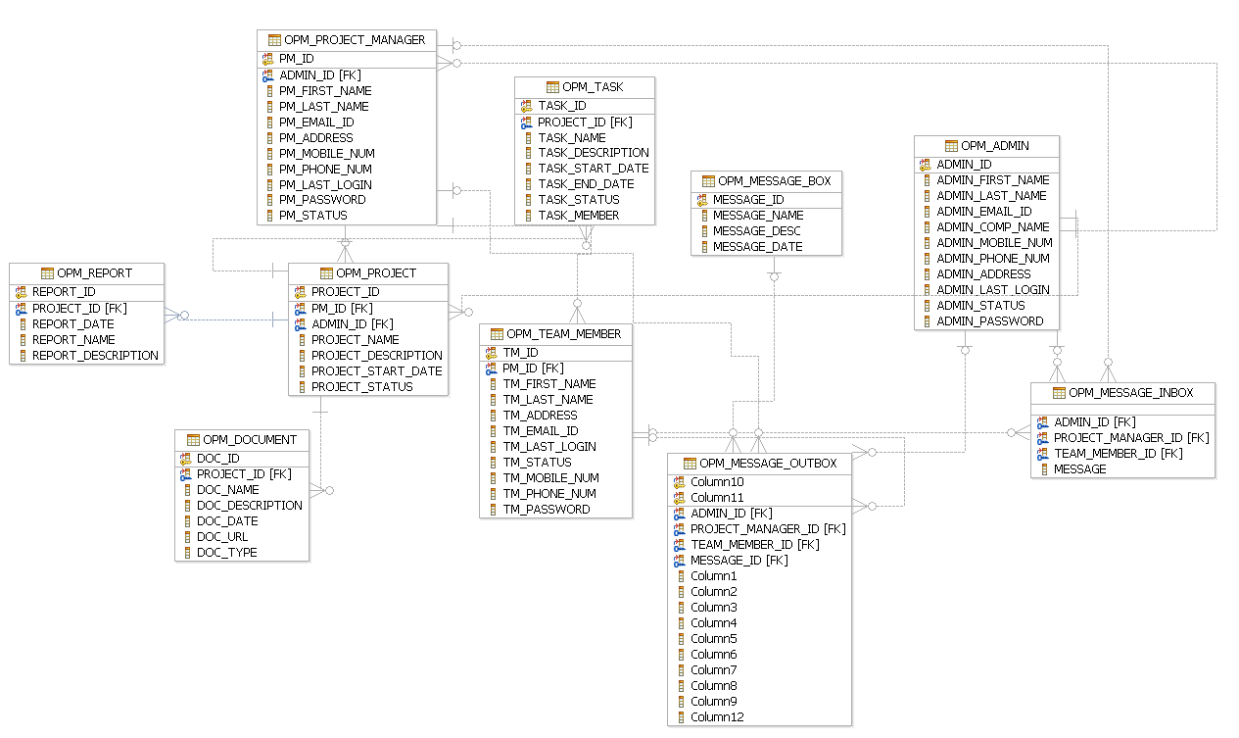

Architecture Diagram

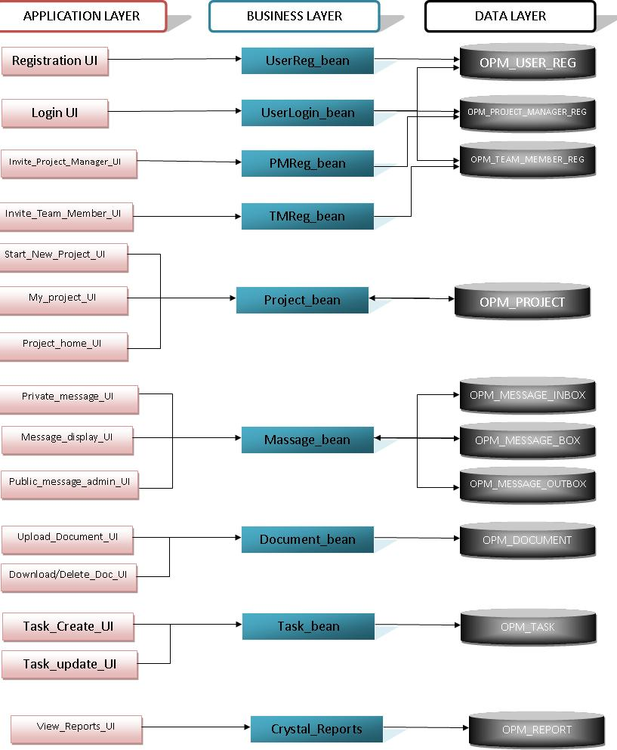

Data Dictionary

All tables used in project

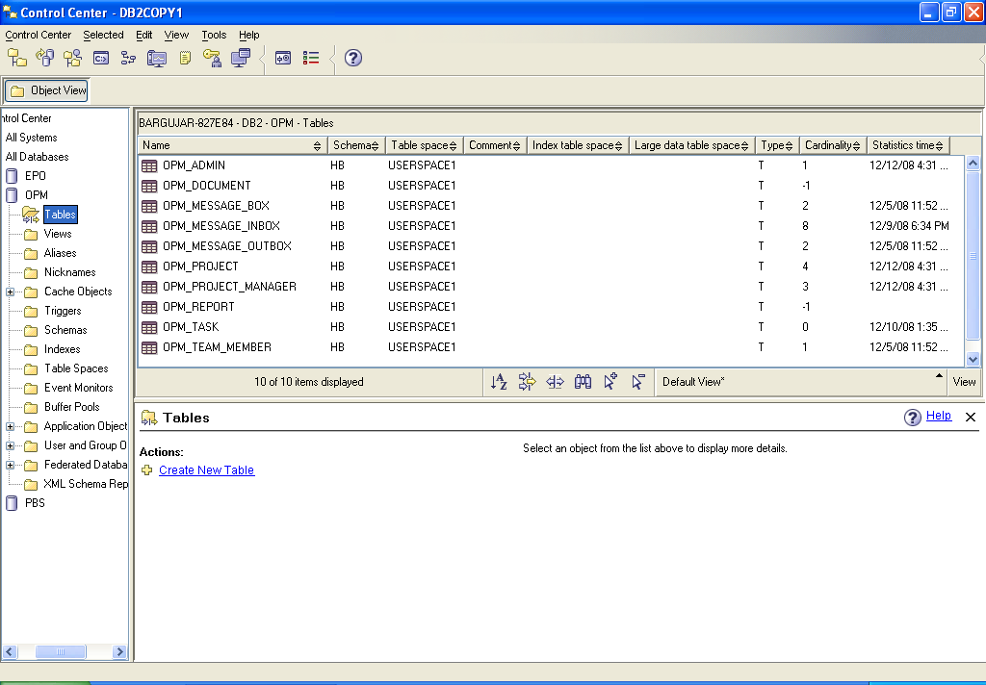

OPM_ADMIN

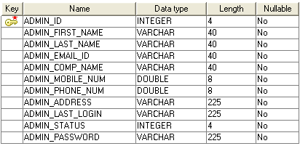

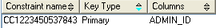

OPM _ PROJECT_MANAGER
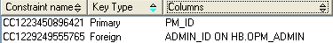
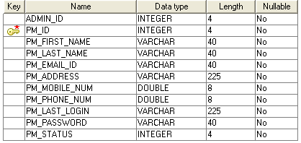

- OPM_TEAM_MEMBER

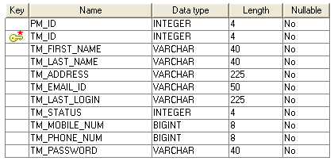

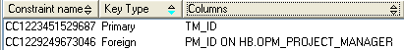

- OPM_PROJECT

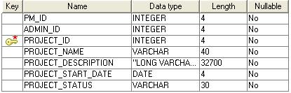

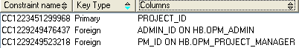

- OPM_TASK

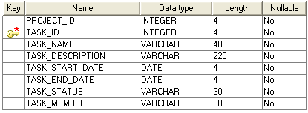

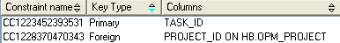

- OPM_DOCUMENTS

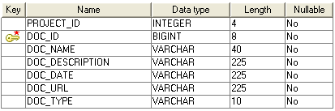

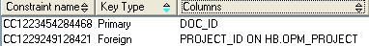
- OPM_MESSAGE_BOX

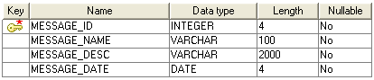

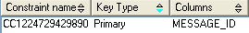

- OPM_MESSAGE_INBOX

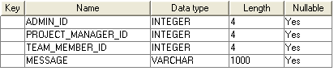

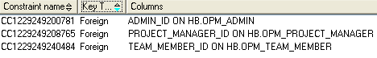

- OPM_MESSAGE_OUTBOX

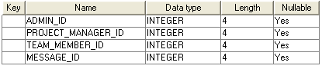

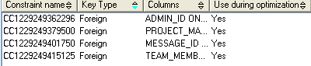

- OPM_REPORTS

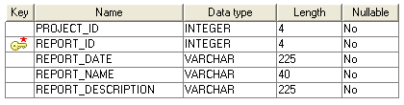

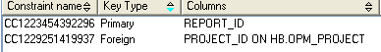

Assumptions and Dependencies

- The Project Manager from same company is not being assigned to two projects.

- Administrator can also be a project manager for a project.

Specific Requirements

Use-Case Reports

- Administrator- is responsible for registering the company and initiating a project, sending invitation mails to the project manager.

  - Start New Project- the admin starts the project which needs to be managed and supervised by the project manager. The Admin provides with the relevant information to the system and initiates a new project.
  - Invite Project Manager- the Admin sends an invitation email to the desired project manager who will be responsible for managing the project so created.

  - Assign Project Manager- the Admin assigns the project manager a particular project on which he/she needs to work.

Name of Use Case - Start New Project.

Description – a new project will be created for the company.

Pre Condition –The Admin should be logged in the system.

Normal Flow of Events –

- A form will open, necessary information will be entered

- A query will be fired to the database.

- An invitation email will be sent to the desired project manager

- Relevant output will be given to the user.

USE CASE DIAGRAM
New Project Details Filled In
Email to Admin for activation

Work Flow Diagram

A new Project details filled in.
An Email is sent to Admin for activation

Name of Use Case – Invite Project Manager.

Description – an invitation email will be sent to project manager for confirmation.

Pre Condition The Admin should be logged in the system.

Normal Flow of Events –

- An invitation email will be sent to Project Manager

- Project Manager will confirm the request.

- Project information will be completed and status will be updated to ready.

USE CASE DIAGRAM

An invitation mail is send to PM
Request confirmation & PM registration
Project Manager
WORK FLOW DIAGRAM

An Invitation Mail is send to PM
PM confirms the Invitation & register to the system

2. Project Manager – is responsible for managing the overall project, it’s tasks, messages, reports, related deadlines and documents

- Invite New Member – the PM is authorized to invite new members for the project and he/she do so by sending them invitation.

- Create New Task – The PM is responsible for creating a new task and assign members to it

- Create Messages – PM can add messages to the project and these messages will be displayed to all the users.

- Provide Documentation - The PM is responsible for providing documentation for the various tasks involved.

- Generate Reports – The PM can generate various types of reports whenever he feels a requirement.

- Update Project Status – The PM can update the project completion status by analyzing the various task completion statuses.

- Decide Deadlines – The PM is responsible for setting project and task deadlines i.e. the start date and the end date.

Name of Use Case – Invite Team Member.

Description – an invitation email will be sent to team member for confirmation.

Pre Condition –

- The Project Manager should be logged in the system.

Normal Flow of Events –

- An invitation email will be sent to Team Member.

- Team Member will confirm the request.

- Project information will be completed and status will be updated to ready.

USE CASE DIAGRAM
Dispatch an Email to invite Team Members
Request confirmation and Registration by Team Member
Project Information will be completed.
Team Member
WORK FLOW DIAGRAM
Dispatch an Email to invite Team Members

Request confirmation and Registration by Team Member

Project Information will be completed

Name of Use Case – Create New Task

Description – PM starts new task and assign team members to it.

Pre Condition –

- The PM should be logged in the system.

Normal Flow of Events –

- A task will be added to the project and timelines will be displayed.

- Team Members will update the task status.

- The Project completion status will also be updated.

USE CASE DIAGRAM
A Task will be added to project
Team Member Update task status
Project Completion status updated
Team Member

WORK FLOW DIAGRAM
Task Is Added to the Project
Team Member updates task status
Project Completion status updated

Name of Use Case – Create New Message.

Description – a new message will be created which will be displayed to all the users.

Pre Condition –

- The PM should be logged in the system.

Normal Flow of Events –

- A Msg will be created by filling in details of the msg.

- This msg will be displayed to all the active users of the project.

USE CASE DIAGRAM

A MSG will be created
Displaying MSG to active user
Team Member

WORK FLOW DIAGRAM
A MSG will be created

Displaying MSG to active user

Name of Use Case – Provide documentation.

Description – a task or project related document will be given to the team members for their guidance

Pre Condition –

- The PM should be logged in the system.

Normal Flow of Events –

- A document will be uploaded to the system.

- Other team members can read the doc.

USE CASE DIAGRAM

Uploading of DOC to system
Accessibility of DOC to other members
Team Member

WORK FLOW DIAGRAM
Uploading of DOC to system

Accessibility of DOC to other members

Name of Use Case – Generate Reports.

Description – a report can be generated by the PM at any instance of time to view the project completion status

Pre Condition –

- The PM should be logged in the system.

Normal Flow of Events –

- A project report will be generated

- A database entry would be made.

USE CASE DIAGRAM
Generation of project report
Enter information to database

WORK FLOW DIAGRAM
Generation of project report

Enter information to database
Name of Use Case – Update Project Status.

Description – a PM can update the project status by looking at the task completion status.

Pre Condition –

- The PM should be logged in the system.

Normal Flow of Events –

- Analyze project tasks.

- Update project completion status.

USE CASE DIAGRAM
Analyze Project task
Update project completion status

WORK FLOW DIAGRAM

Analyze Project task

Update project completion status

Name of Use Case – decide deadlines.

Description – a time line i.e. a start date and an end date would be set for every task.

Pre Condition –

- The PM should be logged in the system.

Normal Flow of Events –

- Set a start date and an end date.

USE CASE DIAGRAM
Set a start date and an end date

WORK FLOW DIAGRAM
Set an start date and an end date

3. Team Member – is responsible for updating task status and completing the task so that the project may not get delayed.

- Update Task Status – the team member is responsible for updating the completion status of the project.

- Create/ update MSG – the team member can create and update the msgs.

Name of Use Case – update task status.

Description – completion status of the task could be updated.

Pre Condition –

- The Team Member should be logged in the system.

Normal Flow of Events –

- Sets the percentage completion status.

USE CASE DIAGRAM
Set the percentage completion status

WORK FLOW DIAGRAM
Set the percentage completion status

Name of Use Case – create/ update MSG.

Description – a new MSG will be created or an already existing MSG will be updated.

Pre Condition –

- The Team Member should be logged in the system.

Normal Flow of Events –

- Create a new msg

- Edit an already existing msg.

USE CASE DIAGRAM
Create a new MSG
Edit an already existing Msg
WORK FLOW DIAGRAM

Create a new Msg

Edit an already existing MSG

Class Diagram
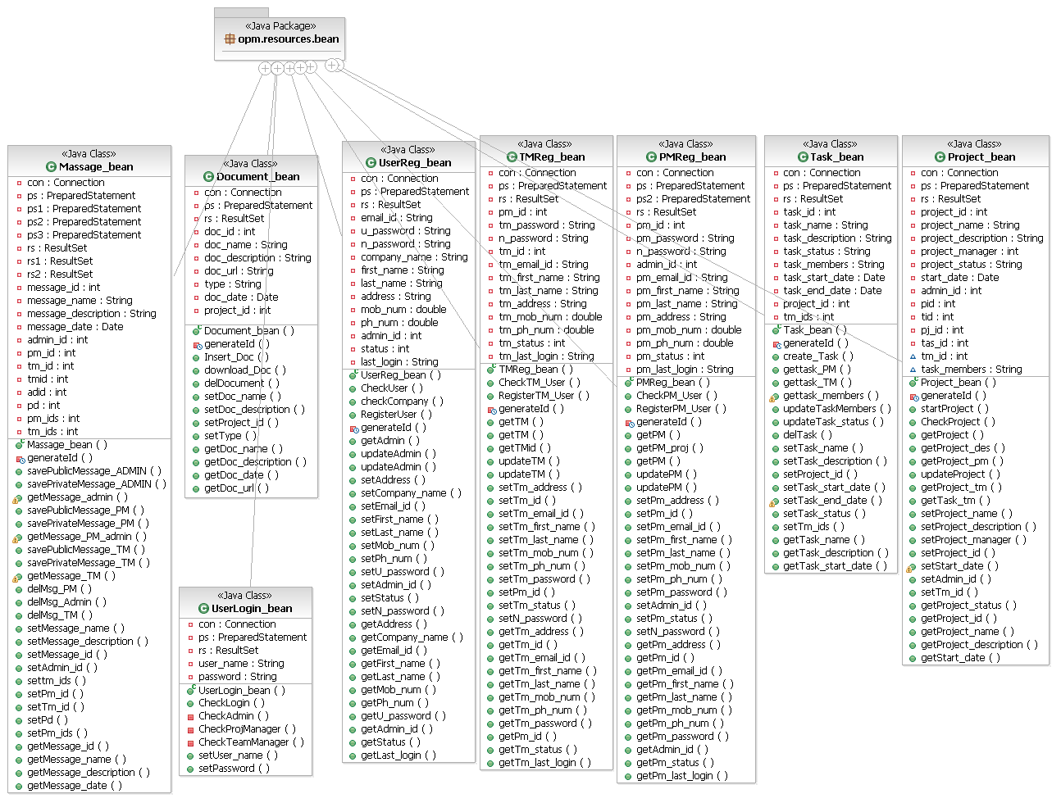

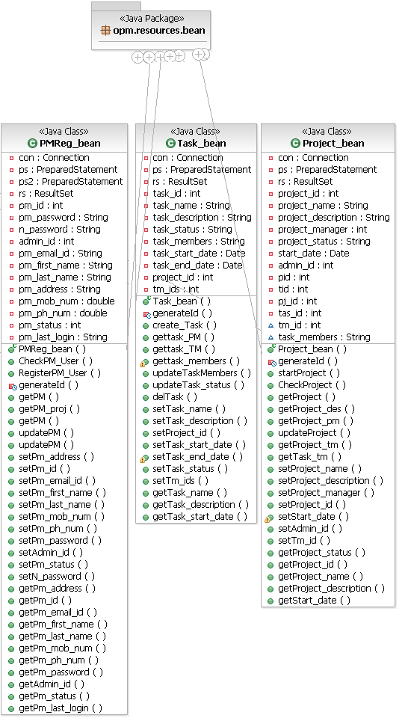

Supplementary Requirements

- Since this a tool which can be used from anywhere and anytime in the world, so the server should be well managed for such kind of requirement.

- The users using this and importing the reports from this tool should have supporting software to run them.

- To use the application in the best possible way please read the tips displayed while using the tool.

